**Selecting the Best Forward Sortation Area (FSA)** **for a New Restaurant in Toronto**

Nassim Al-Abed

July 12, 2019

1. Introduction

Normally site selection is a task that carried out by Geographic Information Systems (GIS) software after specifying several criteria. GIS is very efficient in carrying out, such as task if the needed spatial data and metadata are available. For this project, the use of specialized GIS package is not advisable because we need to apply the knowledge gained in the courses of data science taken during the previous months in solving a site selection problem. Normally starting a new business and opening a new restaurant involves investing time in studying the market and calculating the risk associated with the restaurant site selection. Utilizing the free tools in data science in analysing the freely available data either from the internet or from governmental sources is advantageous.

1.1 Description of City of Toronto:

Toronto is the provincial capital of Ontario and the most populous city in Canada, with a population of 2,731,571 in 2016. Toronto census metropolitan area (CMA) has a population of 5,928,040, making it Canada's most populous metropolitan area. Toronto is the fastest growing city in North America and is the anchor of an urban agglomeration, known as the Golden Horseshoe in Southern Ontario, located on the northwestern shore of Lake Ontario. Toronto is an international center of business, finance, arts, and culture, and is recognized as one of the most multicultural and cosmopolitan cities in the world. The total area of Toronto is 630.2 km2 (<https://en.wikipedia.org/wiki/Toronto>). Figure 1 shows the city’s location and its boundaries. The diverse population of Toronto reflects its current and historical role as an important destination for immigrants to Canada, where above 50 percent of residents belong to a visible minority population group, and over 200 distinct ethnic origins are represented among its inhabitants. While the majority of Toronto residents speak English as their primary language, over 160 languages are spoken in the city. So, we can easily say that Toronto is a global city. In 2016, the three most commonly reported ethnic origins overall were Chinese (332,830 or 12.5%), English (331,890 or 12.3%) and Canadian (323,175 or 12.0%), (<https://en.wikipedia.org/wiki/Toronto>).

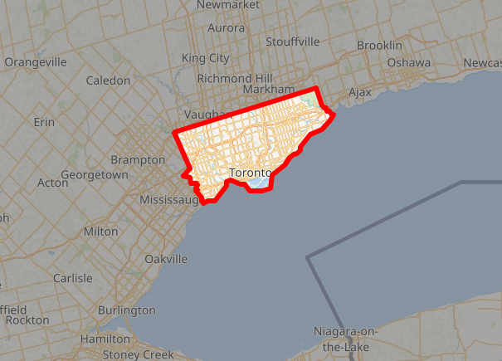

Figure 1. City of Toronto location and boundaries

2.2 Identifying the problem

First, not all of the needed data for this project are readily available, so I had to obtain the raw data and work on cleaning the data and converting the data to the format that I could use in this project. After cleaning and preparing the data Folium could be used in creating a choropleth map that can help us in finding a suitable neighborhood for the new restaurant.

2.3. Identifying the site selection criteria

There are several factors that we could consider in carrying out an exercise similar to this project, but again selecting the approach and identifying the factors that will be considered in the selection criteria depends on the spatial data availability. What I found in this project that spatial data is not freely available for Toronto and utilizing some of the open data involved working on converting the format to the needed format for Folium using a GIS package as will be shown later. In this project, I selected two criteria to be considered for the selected neighbourhood of the new Chines restaurant first one is to have at least 10% of the residents either Chines immigrants or from a Chines decedents, this was considered by assuming that they will favour the Chines cousin. The second criterion considered was the neighbourhood should have the highest population density in Toronto. This criterion was made to make sure that we will have enough potential customers from the same area.